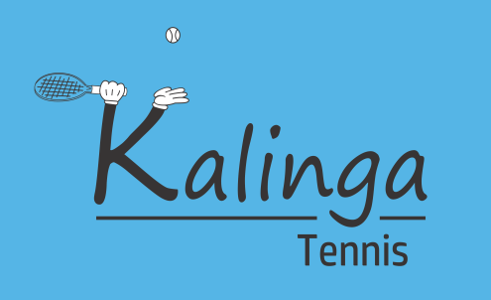
Gail Jones: Advanced Coach, Tennis Coaches Australia, > 20 years experience, former no. 1 in QLD, top 10 Australia, top 200 world, BHMS degree, First Aid, Blue card, Insurance, TA Safeguarding Children course
0411 421 346 gail.jones@optushome.com.au

Term 4 2019 OLHC

Term 4 Tennis Coaching resumes on Tuesday 8th October, first day back at school. Lessons at OLHC are on Monday mornings at first break from 10.45-11.15am, however since the first Monday is a holiday, we will do tennis first break on the Tuesday. All year levels and standards are welcome!

For those students who wish to progress to the next level and start playing matches, there are classes at nearby Kalinga Park where we can spread out over 2 courts and perform more point play. Kalinga Park classes are on Monday, Tuesday and Friday afternoons. Contact Gail to arrange private lessons and or match play for further development or if your child would like to play Super League Tennis Fixtures on a Saturday afternoon. Adult classes are also available on Mondays at 8.45am at Kalinga.

HOLIDAY TENNIS CLINIC will be held during the first week of the holidays from Monday 23rd September to Friday 27th, 8.30-10.30am at Kalinga Park. Morning tea is provided. $10 discount if attend all 5 days. $40/day or $190/week. Intensive training in a fun environment is ideal for improving concentration and fitness.

Please email or text Gail (above) if you are returning to tennis in term 4 and if you are new please fill out the form below and return to the office or give to Gail directly at first lesson. Any questions – call Gail above. Payment is due before the first lesson by cash or direct deposit (BSB: 484799 A/C: 780071650 ) to Gail Jones- insert child’s name & Term4 OLHC. No invoices! Special early bird discount applies if pay by the end of this term.
OLHC
Kalinga Park
30mins $130/term (early bird $125) $190 (early bird $185)

Mon: 10.45-11.15(first break) Mon : 4.15 - 5.15 (Tuesday if Monday holiday) Tues: 3.35-4.35
Fri : 3.15 - 4.15
**Early bird if paid by Friday 20th September
HOLIAY TENNIS CLINIC at KALINGA PARK: $40/DAY $190/WEEEK
-------------------------------------OLHC TERM 4 , 2019-----------------------------------------------

Name……………………………………………………..Class……...Parent’s name…..…………………….…
Email………………………………………………………………………..Mobile…………………………………….
Select your preferred class: if choosing Kalinga Park
Day……………………………..Time………………..….Amount………..how paid………when paid………..
Holiday tennis clinic (Kalinga)…………(yes/no) TEXT GAIL 0411421346

