PIANO &
GUITAR
LESSONS
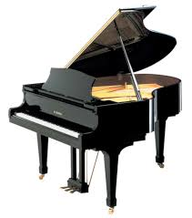
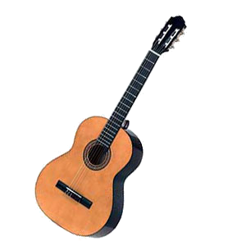
Parents wanting to enrol their child in keyboard or guitar lessons in the OLHC Instrumental Program are asked to complete the attached form and hand it into the school office.

Mrs Anne-Maree Eyles will be taking the Instrumental lessons. Mrs Eyles has taught Instrumental music for over 20 years. She currently teaches Instrumental music at Brisbane Girls Grammar and St Benedict's College as well as Classroom Music at OLHC.

Lesson Structure:
Lessons will commence in Week 4 of Term 1 and will be held every Monday during the school term, on school days (i.e. not on public holidays or pupil free days). Students will receive instrumental instruction in small groups of 2-3 students for 30 minutes per week. Individual lessons are available depending upon time availability and student instrumental skill level.

Prices for Term 1 2017 are:
Individual lesson (1 student) - $30 per 30 min lesson - $210 for Term 1 (seven weeks)
Group lesson - $18 each student per 30 min lesson - $126 for Term 1 (seven weeks)

These 2017 prices are lower than the minimum fee recommended by the Music Teachers Association of Queensland.

All prices listed include GST. Please note also, that we provide lessons and classes by the term, not per single session. Please give 24 hours notice if your child is going to be absent from lessons, to receive a credit. Lessons will occur during school time. You will need to purchase an instrument and a music book and these details will be given to students at the first lesson.

Contact Details:
Parents can contact me at:
Anne-Maree Eyles [aeyles@bne.catholic.edu.au]

Thank you for giving your child the opportunity to develop their musical talents.

Regards
Anne-Maree Eyles
OLHC
INSTRUMENTAL MUSIC ENROLMENT FORM

Student Name: ______________________________________ Year: _________

I would like to enrol in (please tick): Individual Lessons ____ Group Lessons ____

Instrument (please tick): Keyboard Lessons ______ Guitar Lessons __________

Student has learnt this instrument for: __________ years
Comments (optional): ________________________________________________________
___________________________________________________________________________

Parent/Guardian Permission:
We agree to enrol our student for a minimum period of a term and pay fees directly to the instrumental teacher at the beginning of each term. We will advise the instrumental teacher in writing two weeks prior to the end of term if we wish to discontinue lessons. We understand that tuition fees are non-refundable. We agree that our student will regularly attend lessons. We understand that lessons will only be rescheduled in the case of a student’s valid absence and when 24 hours prior notice has been sent to the instrumental teacher. In the case of absence we are to contact the instrumental teacher directly via email prior to the lesson.

Parent/Guardian Name: ______________________________________________________
Signed: ____________________________________________________________________
Contact number: _____________________________________________________________
Email address:_______________________________________________________________

